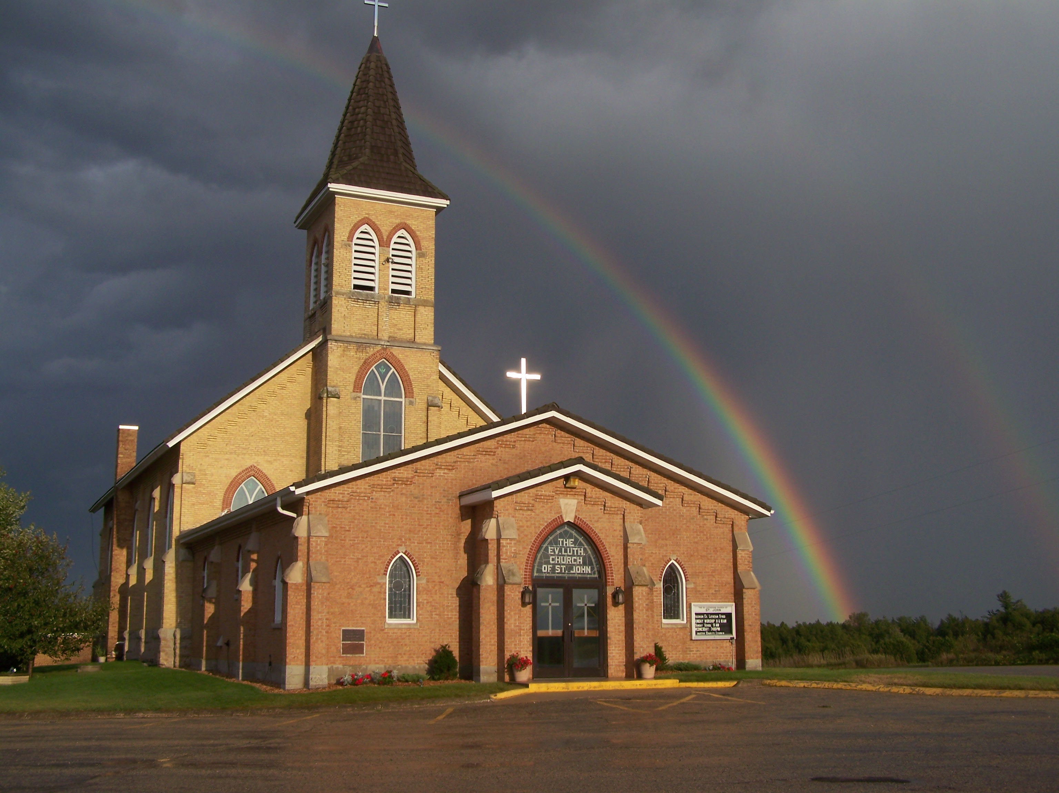
The Evangelical Lutheran Church of St. John
N1916 Church Road
Peshtigo, Wisconsin 54157-9673
Pastor Sargent 920-228-1061

09/10/2020
Dear members of St. John,
It is a silly and somewhat tiring song and dance. Perhaps you have heard of it or even experienced it at a wedding. It is called the hokey pokey. The song and dance tell you to put your left arm, right arm, left leg and right leg into the circle, shake it all about, and do the hokey pokey. At the end you put your whole self in!
Our text for Sunday (Romans 12:1-8) reminds me of this dance. When I think of the phrase “put your whole self in!” it sounds like what Paul is encouraging us to do in this text. “To offer your bodies” is Paul’s way of saying, “Put your whole self in.” Therefore, I urge you, brothers and sisters, in view of God’s mercy, to offer your bodies as a living sacrifice, holy and pleasing to God—this is your spiritual act of worship. This is not a silly song and dance we do at weddings. This is our spiritual act of worship. And God says, “Put your whole self in!
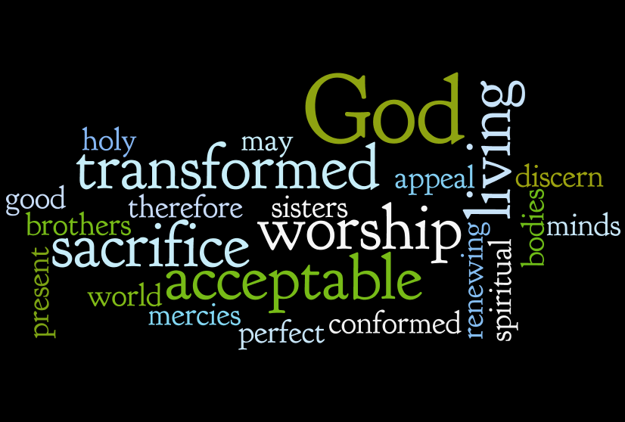 (Romans 12:1-2)
Worship
We will worship with no more than 100 people in attendance for each service. At this time, we will not need to sign up before services because we have not gone beyond the occupancy limit. If that happens, we will go to the sign up again.
Mask Mandate:
The Governor has issued a State-wide Mask Mandate for all public indoor meetings. We will be following this mandate during worship services. If you do not haver a mask one can be provided for you by an usher.
Note: Those with medical conditions or other sensory sensitivities that prevent someone from being able to wear a mask may be exempt according to the Mandate.
- There will be two services on Sunday at 8:30 and 10:00.
- We will worship with no more than 100 people in attendance for each service.
- We will have portions of the church pews partitioned off to accommodate social distancing. Please be sure to sit only in the apportioned sections. Ushers will guide you to your seat of choice.
- No hymnals will be used. All service materials will be printed in the church bulletin, handed out to each member by an usher wearing a mask and gloves.
- We will not be passing offering plates in the worship service but will have them at the doors of the sanctuary where you may drop your offering.
- When church is over you will be ushered out. Please don’t get up and leave on your own. That will make it difficult to keep proper social distancing.
- We are requiring that everyone wear a facemask and please remember social distancing.

Social Interaction

In order to maintain responsible social distancing, we are strongly encouraging the following:
- No physical contact: handshakes, hugs, fist bumps, etc.
- No gathering within church for socializing either before or after services.
- At this time all other church events, Bible Study, Sunday School, Ladies Aid and Quilting (etc.) will be on hold.

- If you are not feeling well or have concerns about your own health, you do not need to attend. We will continue with the Livestreaming service at 8:30. If you would like to receive private communion at home please contact Pastor Sargent.

http://www.facebook.com/The-Evangelical-Lutheran-Church-of-St-John-Town-of-Grover-WELS-100389558275581/
https://www.youtube.com/channel/UCJ8tkCadzLHuxGWLhovgl8Q
Reminder of Important Information:


Snow Plowing:



The Board of Education is looking to hire someone to do the snow plowing of the school parking lot this winter. It would require someone to be able to do the plowing before 7:00 am each time it snows. If you are interested please contact the School at email school@stjohnpeshtigo.org or call Pastor Sargent (920-228-1061)

Sunday School:



Attention Parents!

In light of current challenges related to classroom gatherings because of the pandemic, our church is introducing a new approach to Sunday school. Beginning Sunday, September 13, lessons taught by experienced WELS teachers will be available free via YouTube. The engaging and age appropriate Lesson Videos will tie to printed Student Lessons that our church will provide to you at no cost. This new approach presents an easy yet meaningful way for you to encourage your child’s faith in Christ. To see the lesson for Sunday, September 13 Lesson Video and Student Lesson, visit nph.net/ss-at-home. Printed Student Lessons for your child will be available for pick-up at church on Sunday the 13th of September.
If you have not registered your child for Sunday School lessons it is not to late. Please see the sing up sheets in the back of the Church or you contact Pastor at dsargentzambia@gmail.com or call 920-228-1061. Materials for the students will be ordered and paid for by the church.
For more information see: https://online.nph.net/ss-remote

Livestreaming Volunteers:

We are looking for volunteers to help with the 8:30 service livestream broadcast. This is not a complicated program but needs volunteers who would be willing to learn to turn on the computer and press the needed buttons to start the live feed and move the camera during the service. Please contact Pastor is you are interested.


Pastor Daniel Sargent

